**Lesson 09 Demo 01**

**Next-js-simple-welcome-app**

**Objective:** To demonstrate the next js application to display simple welcome message.

**Tools required:** Node JS and React JS

**Prerequisites:** HTML, CSS, JavaScript ES5/ES6, Basic React Concept

**Note** : All react js project already created with version 18.x with Sample App.js file

**Steps to be followed:**

1. Set up for next js project
2. Project structure
3. Now we run the application.

**Step 1: Set up for next js project**

1. First time you need to install the create-next-app npm third party modules

**npm install -g create-next-app**



1.2 create new project using **create-next-app** command.

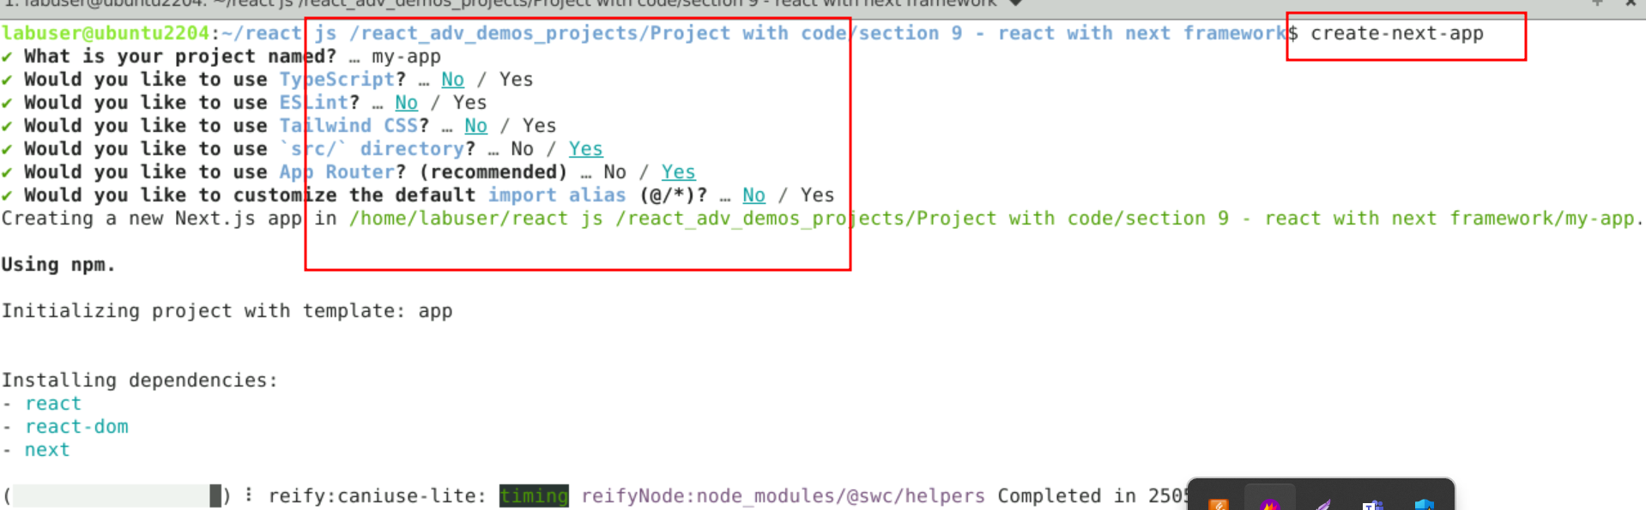

* 1. Project name is **my-app**
  2. Typescript : **no**
  3. ESLint : **no**
  4. Taiwind css : **no**
  5. Src / directory : **yes**
  6. App router **: yes**
  7. Customize the default **: yes**
  8. Now open **my-app** folder in VS Code Editor

Note: short cut to open write **code .**

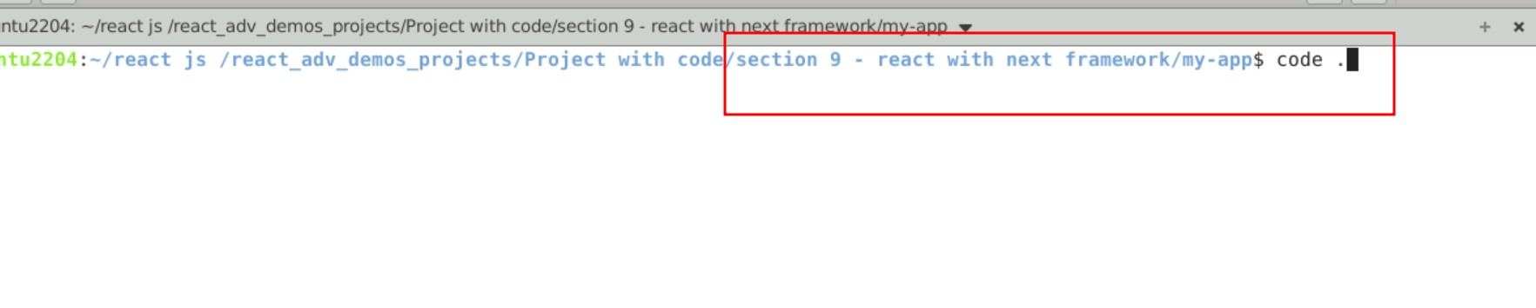

* 1. view the project structure

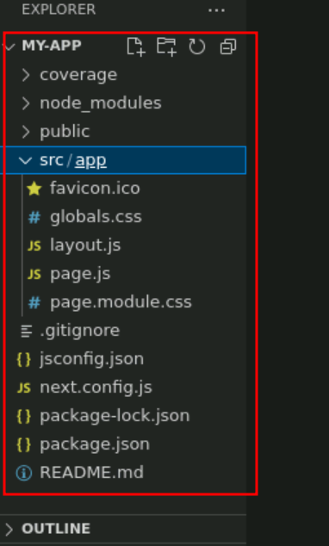

**Step 2: project structure**

2.1 project structure file details

a. next.config.js contains configuration file for Nex.js

/** @type {import('next').NextConfig} */

const nextConfig = {}

module.exports = nextConfig

b. package.json file Project dependencies and scripts

{

"name": "my-app",

"version": "0.1.0",

"private": true,

"scripts": {

"dev": "next dev",

"build": "next build",

"start": "next start",

"lint": "next lint"

},

"dependencies": {

"react": "^18",

"react-dom": "^18",

"next": "14.0.4"

}

}

c. layout.js: this file is responsible to render the next js component on server side.

import { Inter } from 'next/font/google'

import './globals.css'

const inter = Inter({ subsets: ['latin'] })

export const metadata = {

title: 'Create Next App',

description: 'Generated by create next app',

}

export default function RootLayout({ children }) {

return (

<html lang="en">

<body className={inter.className}>{children}</body>

</html>

)

}

d. first next js component code present in page.js file

import Image from 'next/image'

import styles from './page.module.css'

export default function Home() {

return (

<main className={styles.main}>

<div className={styles.description}>

<p>

Get started by editing&nbsp;

<code className={styles.code}>src/app/page.js</code>

</p>

<div>

<a

href="https://vercel.com?utm_source=create-next-app&utm_medium=appdir-template&utm_campaign=create-next-app"

target="_blank"

rel="noopener noreferrer"

>

By{' '}

<Image

src="/vercel.svg"

alt="Vercel Logo"

className={styles.vercelLogo}

width={100}

height={24}

priority

/>

</a>

</div>

</div>

<div className={styles.center}>

<Image

className={styles.logo}

src="/next.svg"

alt="Next.js Logo"

width={180}

height={37}

priority

/>

</div>

<div className={styles.grid}>

<a

href="https://nextjs.org/docs?utm_source=create-next-app&utm_medium=appdir-template&utm_campaign=create-next-app"

className={styles.card}

target="_blank"

rel="noopener noreferrer"

>

<h2>

Docs <span>-&gt;</span>

</h2>

<p>Find in-depth information about Next.js features and API.</p>

</a>

<a

href="https://nextjs.org/learn?utm_source=create-next-app&utm_medium=appdir-template&utm_campaign=create-next-app"

className={styles.card}

target="_blank"

rel="noopener noreferrer"

>

<h2>

Learn <span>-&gt;</span>

</h2>

<p>Learn about Next.js in an interactive course with&nbsp;quizzes!</p>

</a>

<a

href="https://vercel.com/templates?framework=next.js&utm_source=create-next-app&utm_medium=appdir-template&utm_campaign=create-next-app"

className={styles.card}

target="_blank"

rel="noopener noreferrer"

>

<h2>

Templates <span>-&gt;</span>

</h2>

<p>Explore starter templates for Next.js.</p>

</a>

<a

href="https://vercel.com/new?utm_source=create-next-app&utm_medium=appdir-template&utm_campaign=create-next-app"

className={styles.card}

target="_blank"

rel="noopener noreferrer"

>

<h2>

Deploy <span>-&gt;</span>

</h2>

<p>

Instantly deploy your Next.js site to a shareable URL with Vercel.

</p>

</a>

</div>

</main>

)

}

e. global.css file contains global css styling

:root {

--max-width: 1100px;

--border-radius: 12px;

--font-mono: ui-monospace, Menlo, Monaco, 'Cascadia Mono', 'Segoe UI Mono',

'Roboto Mono', 'Oxygen Mono', 'Ubuntu Monospace', 'Source Code Pro',

'Fira Mono', 'Droid Sans Mono', 'Courier New', monospace;

--foreground-rgb: 0, 0, 0;

--background-start-rgb: 214, 219, 220;

--background-end-rgb: 255, 255, 255;

--primary-glow: conic-gradient(

from 180deg at 50% 50%,

#16abff33 0deg,

#0885ff33 55deg,

#54d6ff33 120deg,

#0071ff33 160deg,

transparent 360deg

);

--secondary-glow: radial-gradient(

rgba(255, 255, 255, 1),

rgba(255, 255, 255, 0)

);

--tile-start-rgb: 239, 245, 249;

--tile-end-rgb: 228, 232, 233;

--tile-border: conic-gradient(

#00000080,

#00000040,

#00000030,

#00000020,

#00000010,

#00000010,

#00000080

);

--callout-rgb: 238, 240, 241;

--callout-border-rgb: 172, 175, 176;

--card-rgb: 180, 185, 188;

--card-border-rgb: 131, 134, 135;

}

@media (prefers-color-scheme: dark) {

:root {

--foreground-rgb: 255, 255, 255;

--background-start-rgb: 0, 0, 0;

--background-end-rgb: 0, 0, 0;

--primary-glow: radial-gradient(rgba(1, 65, 255, 0.4), rgba(1, 65, 255, 0));

--secondary-glow: linear-gradient(

to bottom right,

rgba(1, 65, 255, 0),

rgba(1, 65, 255, 0),

rgba(1, 65, 255, 0.3)

);

--tile-start-rgb: 2, 13, 46;

--tile-end-rgb: 2, 5, 19;

--tile-border: conic-gradient(

#ffffff80,

#ffffff40,

#ffffff30,

#ffffff20,

#ffffff10,

#ffffff10,

#ffffff80

);

--callout-rgb: 20, 20, 20;

--callout-border-rgb: 108, 108, 108;

--card-rgb: 100, 100, 100;

--card-border-rgb: 200, 200, 200;

}

}

* {

box-sizing: border-box;

padding: 0;

margin: 0;

}

html,

body {

max-width: 100vw;

overflow-x: hidden;

}

body {

color: rgb(var(--foreground-rgb));

background: linear-gradient(

to bottom,

transparent,

rgb(var(--background-end-rgb))

)

rgb(var(--background-start-rgb));

}

a {

color: inherit;

text-decoration: none;

}

@media (prefers-color-scheme: dark) {

html {

color-scheme: dark;

}

}

**Step 3 :Now we run the application.**

3.1 open the terminal inside the project and run the application we need to use the command as

**npm run dev**

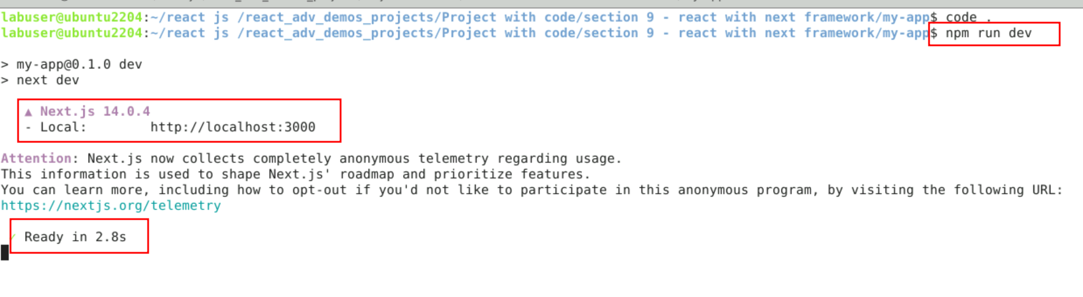

3.2 Now open the browser and write the URL as

<http://localhost:3000>

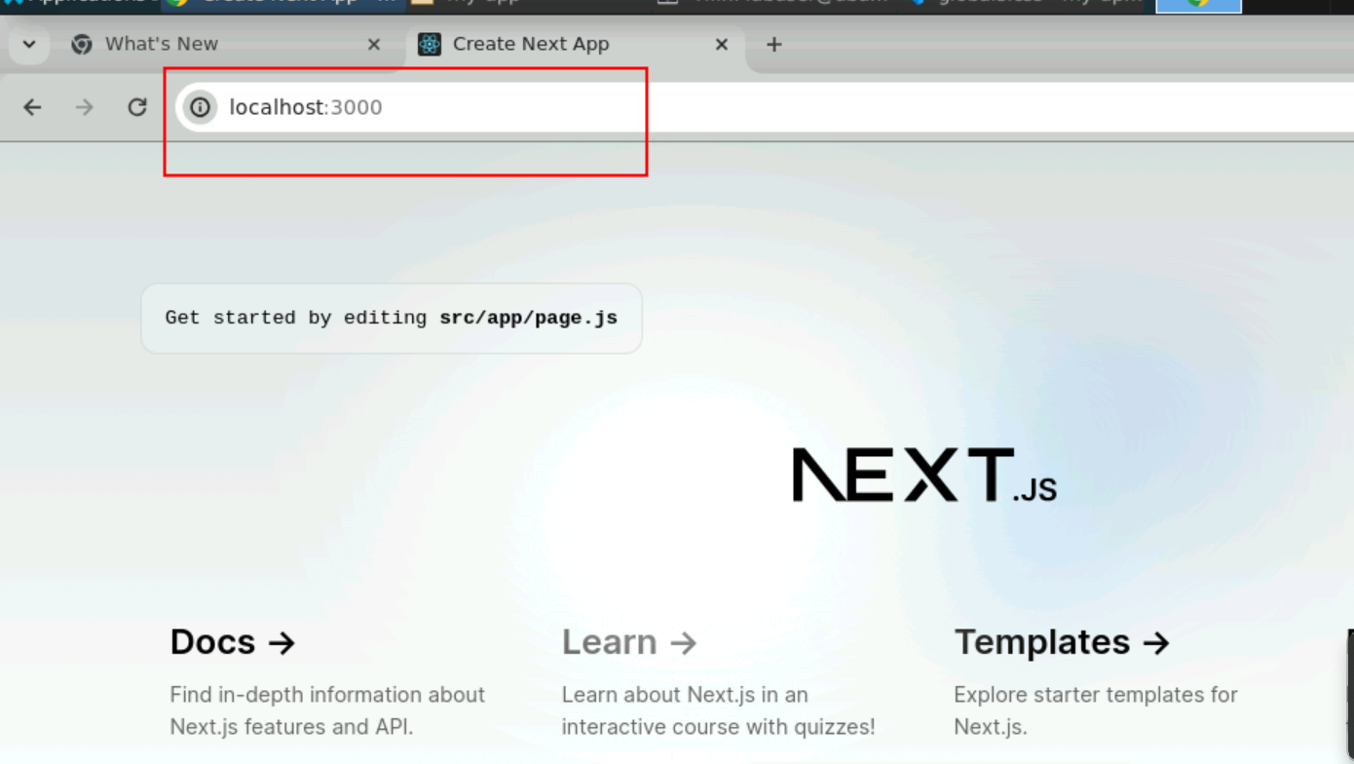

3.3 we will edit the file page.js file which is first next js server side component render with the help of layout.js file

Page.js

import Image from 'next/image'

import styles from './page.module.css'

export default function Home() {

return (

<main className={styles.main}>

<div>

<h2>Welcome to simple next js application!</h2>

</div>

</main>

)

}

3.4 now we will view the output on browser.

